Probability

Basic theoretical probability

Intro to theoretical probability
Coin
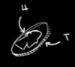

Fair coin:equal chance of landing on one side or another. Its not more likely to land on one side. Its equally likely.
A random event
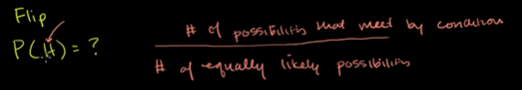
Imagine a box with 1000 coins and u shake the box, if u see the number of heads will be 50%
Or my words their mean would be close to 50.
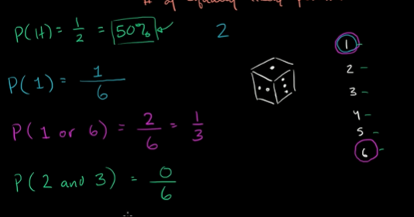

P(2 and 3) is Zero. Cuz its a mutually exclusive events, they both cant happen at the same time.

Simple probability: Yellow marble
trial: picking something out of the bag.
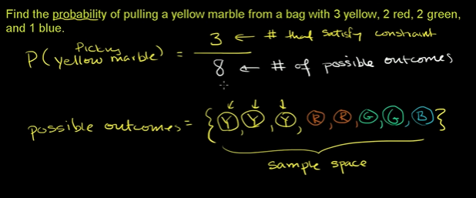
Set of all possible outcomes: Sample space.

Simple probability: non-blue marble
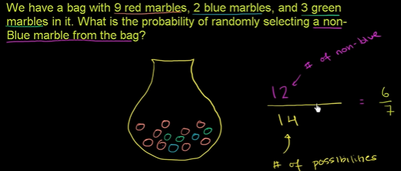
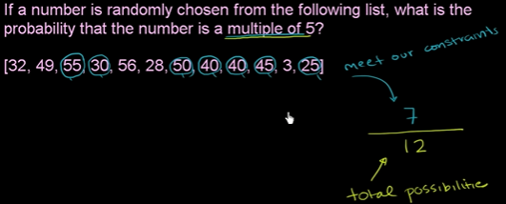

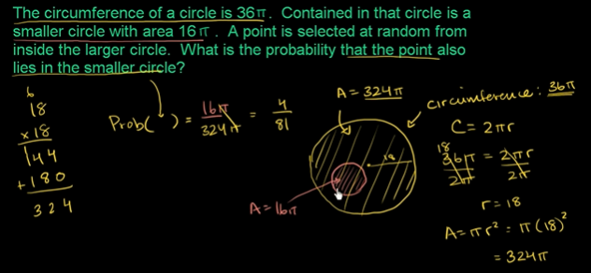

Intuitive sense of probabilities
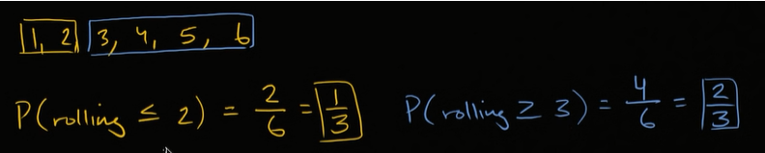
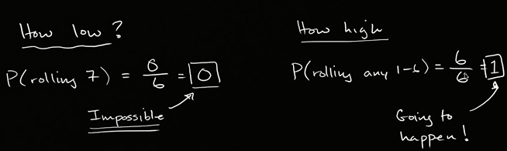

The Monty hall problem

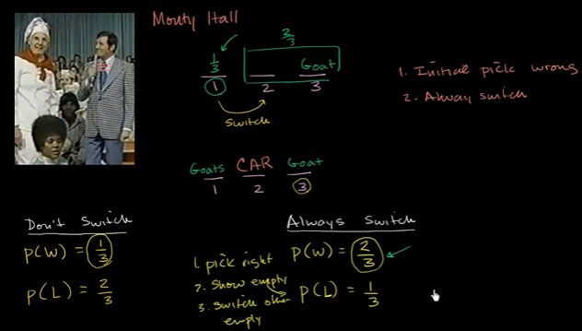
Probability using sample space

Probability with counting outcomes

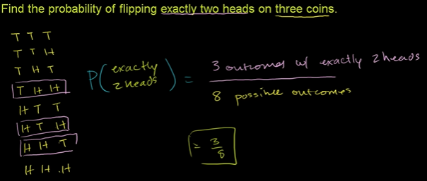
Die rolling probability
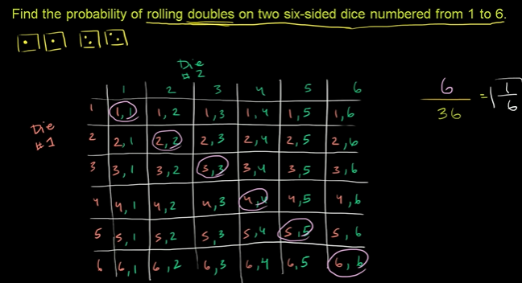

Subsets of sample spaces
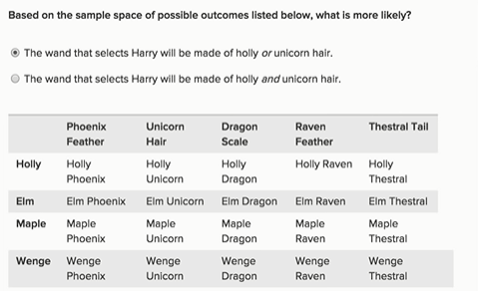

Basic set operations

Intersection and union sets
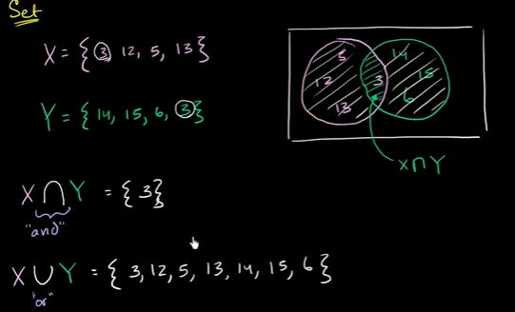

Relative complement or difference between sets
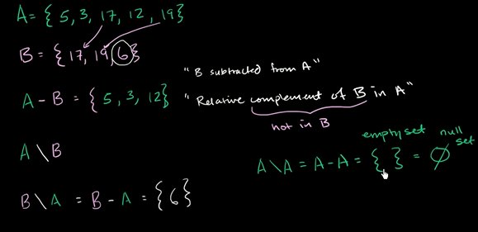

Universal set and absolute complement
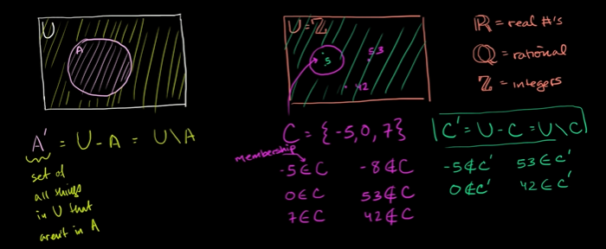

Subset, strict subset, and superset
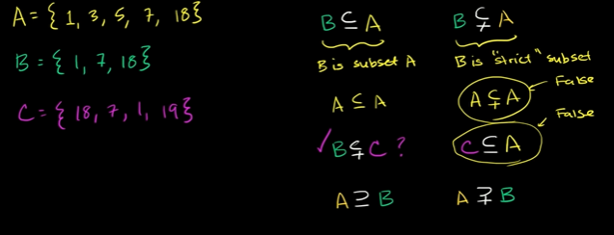
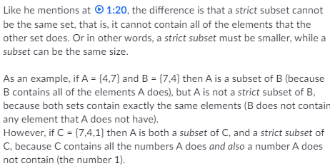

Experimental probability

Experimental probability
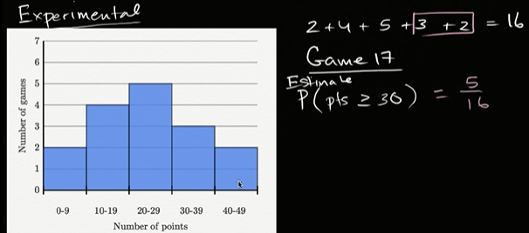
There are a lot of factors, that contribute. This is one of the way to estimate what would happen.

Theoretical and experimental probabilities
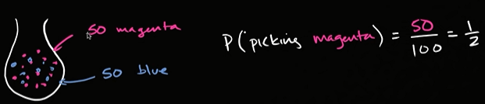
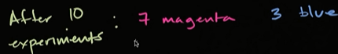

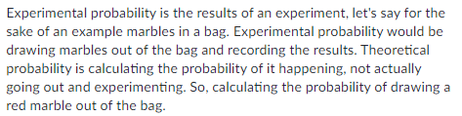

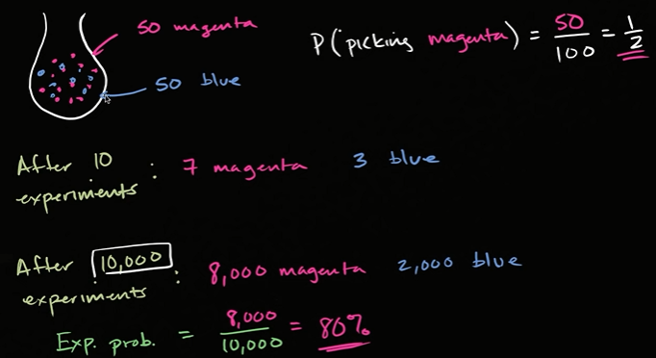
for 10 trials, you might not worry
after 10k, trials: there must be a reason
for e.g the blue marbles are heavier and they happen to settle at the bottom or they are slippery so u end up picking up a red marble.

Randomness, probability and simulation

Experimental versus theoretical proabability simulation
Is explore how experimental probability should get closer and closer to theoretical proabability as we conduct more and more experiments or trials.
If we have very few experiments, its very possible that our experimental probability could be very different from our theoretical probability.
As we have large no of experiments, the probability that the theoretical and experimental proabability are different goes down dramatically.
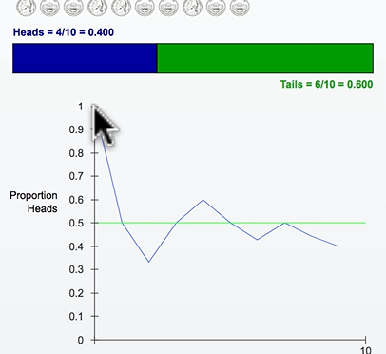
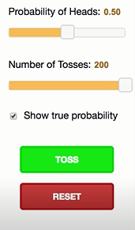

Our theoretical proabability is 5.
Above,
first trial we got ,Head ,Experimental proabability was 1.
Second trial we got, tail, Experimental proabability of getting head ½ I.e 0.5
Third trial we got, tail, Experimental proabability of getting head 1/3 ie. 0.333
So on and on.

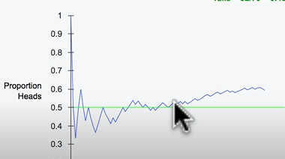
The thing is we are getting Head quite a lot.

More trials
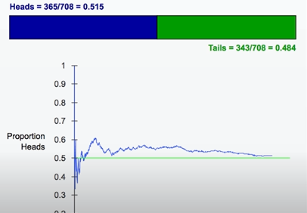
it will converge to 0.5 experimental proabability eventually.

The thing is as we do more and more trials, we are less affected by a single head.
Thats why we see a very small variation.

Random number list to run experiment
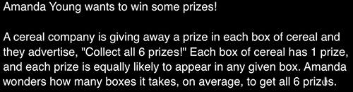

Several ways for amanda to figure out, there maybe a mathematical way to determine what is the expected number of boxes she would need to collect on average to get all six prices.
Or she could run some random numbers simulate collecting box after box after box and figure out multiple trials on how many boxes does it take to win all six prices.
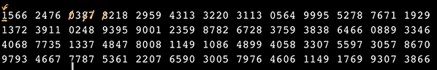
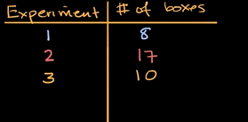
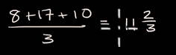

So do we know this is the true theoretical expected number of boxes, that you would need to get. No, we don’t know that. The more experiments we run the closer are average likely to get to the true theoretical average.

Random numbers for experimental probability
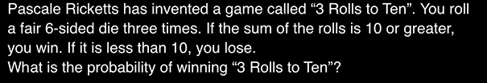
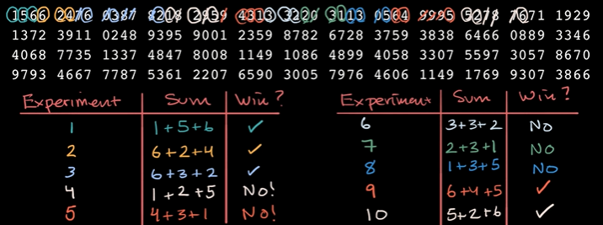
5/10=50%.

Statistical significance of experiment
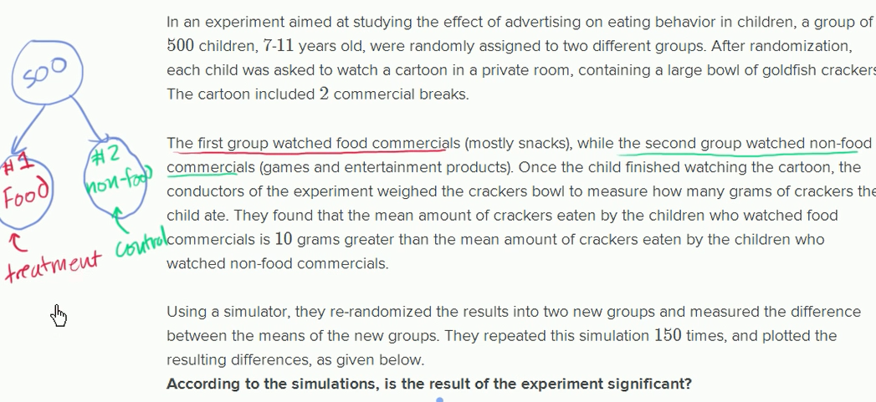

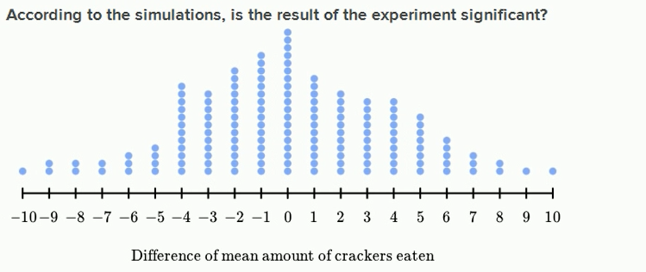
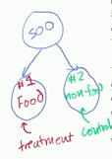
second group watch non food commercials ( games and entertainment products).
After watching cartoon, the childre who watch food commericals is 10g greater than the mean amount of crackers eaten by the children who watched non-food commercial.

The question you have to ask yourself did that happen by chance?
You may say regardless of commercial, it happened to be the case.
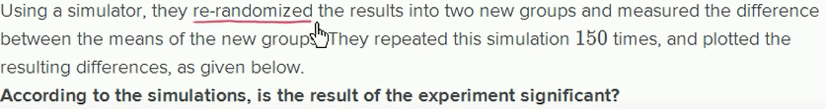
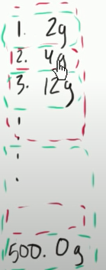
They are mixing up the result they have.
So its completely random the students have watched the food commercial or not.
They are seeing whats the mean of number 1 and 2 group.
So they are seein what are the distribution of the differences in the mean.

So when you put result into two random buckets, you’ll see a bunch of cases where you see no difference in the mean.
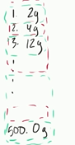
Out of the 100 times, they did this experiment.
They found 19 times there is no noticeable difference from the mean when you just randomly allocate the result amongs the two group.

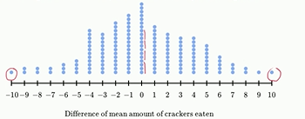
to get 10% greater than mean It happened 1/150 times.

Since 1/150 is quite small, so our experiment was significant.

Proabability with Venn diagrams
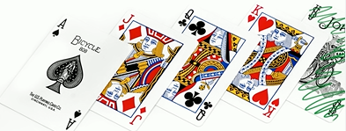

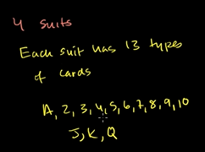
spades,diamond,clubs,hearts

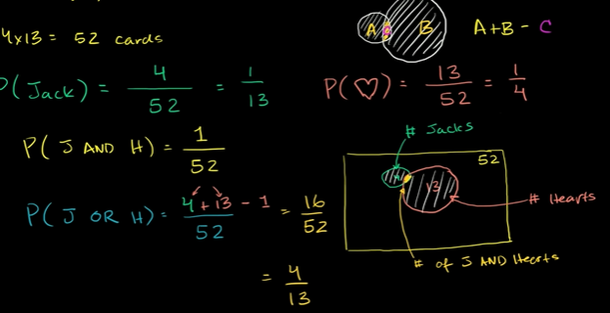

Addition rule for probability
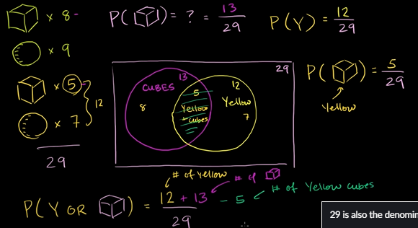

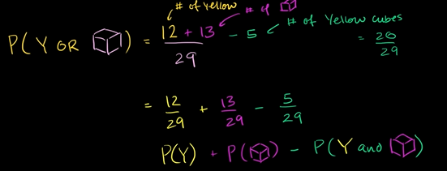

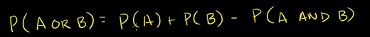

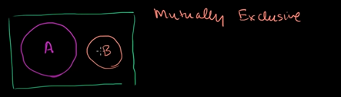

Mutually exclusive means the events cant happen at the same time.
So here you can
P(A or B)=P(A)+P(B)

Multiplication rule for independent events

Sample space for compound events
Sample space isnt telling that they are equally likely or not
Its just tell us if you do a experiment what are all the possible outcomes.
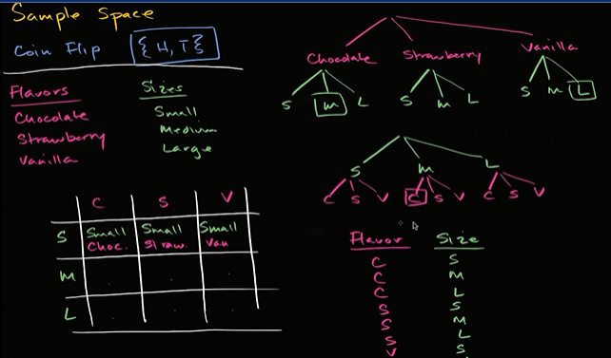

compound sample space, it can vary in two different ways. Not just one.

Compound proabability of independent events
Toss of a coin to get head or tail, they are independent events, so what happen in the first flip in no way affects what happens in the second flip.
Its the gambler falacy that if I got bunch of heads in a row, its more likely to get them tail, that is false.
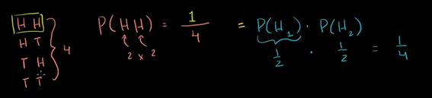
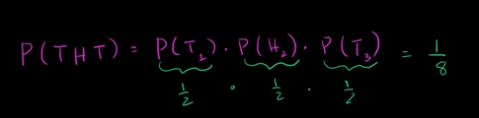

Proabability of a compound event
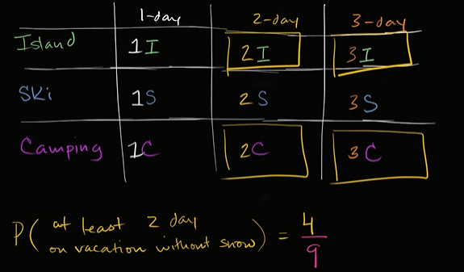

At least one proabability with coin flipping
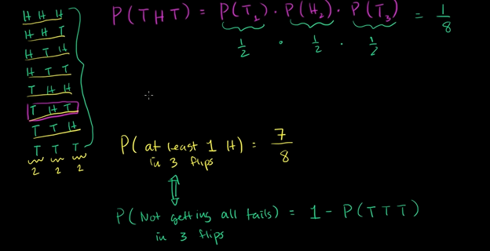
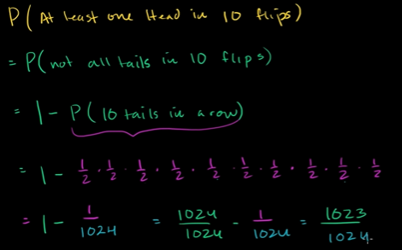

Die rolling probability with independent events
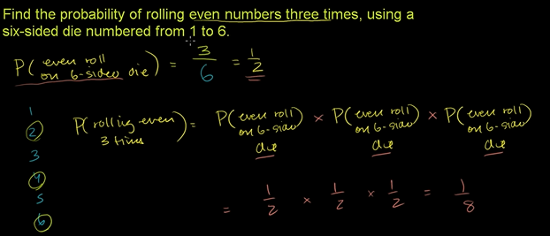

Dependent probability introduction
3 Green, 2 orange marbles in a bag.
If you able to pick two green marbles, you gonna win the prize.
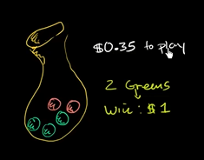
The question is would u want to play this game, don’t put fun factor into, economically, does it make sense for you to play.

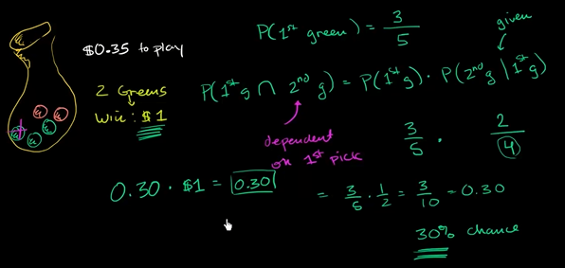

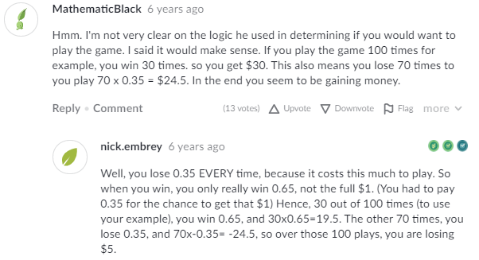

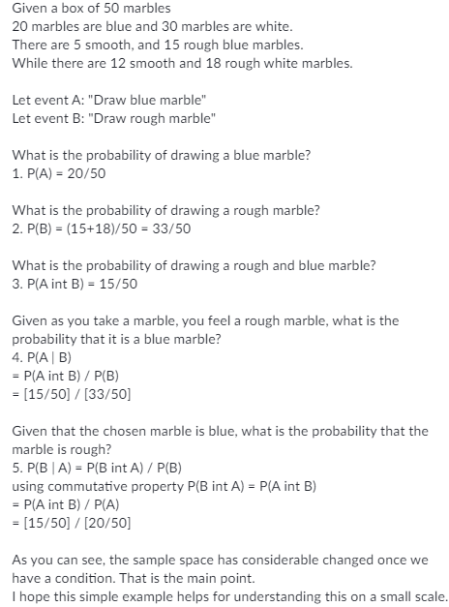

Independent & dependent probability

Independent events: is outcome of one event doesn’t effect outcome of the other event.
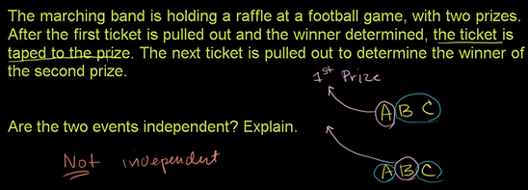

If the ticket after being pulled out was put in back into the bag, then it would be independent events.

Dependent probability
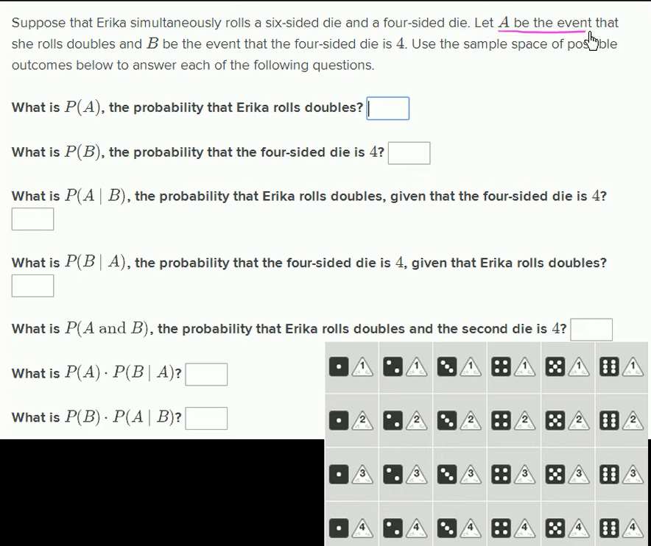
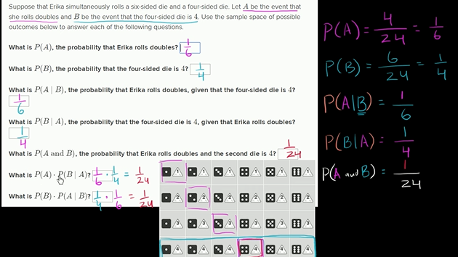

Conditional proabability and independence

Calculating conditional probability
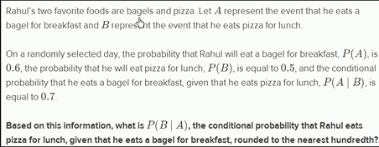

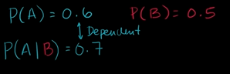
Here P(A) Is different when P(A/B) is different it tells us, they are independent events.
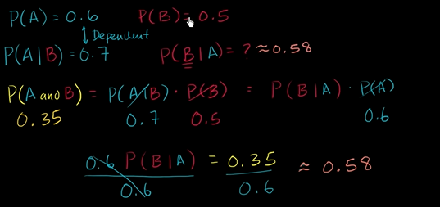

Conditional proabability explained visually ←click
Bobs is in a room, he has 2 coins: one fair coin and one double sided coin , he picks one at random, flips it and show the result.
What is the probability he flipped the fair coin?
At first attempt he flipped one of two coins, so our trees leads to two branches leading to two equally likely outcomes,fair or unfair.
The next attempt he flips again he grow again.
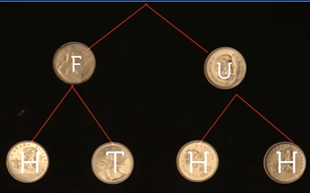
The unfair coin lead to HH, While fiar has H and T.
Our trees is finished and it has 4 leaves, representing four equally likely outcomes.

Final step, whenever we gain evidence we must trim our tree.
We cut any branch that leading to tail, because we know tails did not occur.
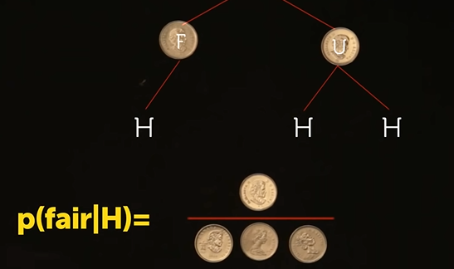

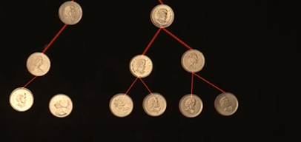
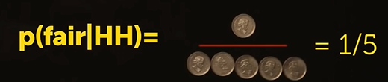

Our confidence in fair coin is dropping as more head occurs.
Though realize we never reach zero. No matter how many flips occur. We can never be 100% sure that the coin is unfair.
All conditional proabability questions can be solved by growing trees.
Problem. Bob has 3 coins: 2 are fair, 1 is biased which is weighted land heads 2/3 of the time, tails 1/3.
He chooses a coin in random and flips it.
Question:What is the probability that he choose the biased coin?
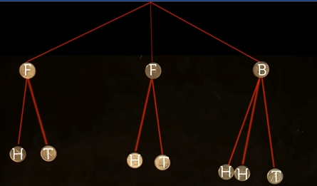

The trick is always make sure our tree is balanced, meaning equal amount of leaves growing out of each branch to do this, we scale up the number of branches to lcm .
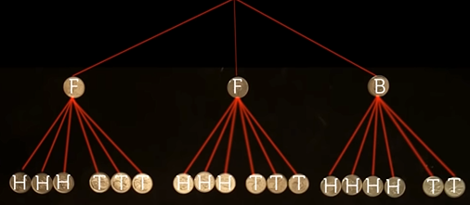

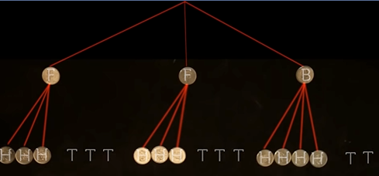
Trim all branches of Tail, since tail didn’t occur.
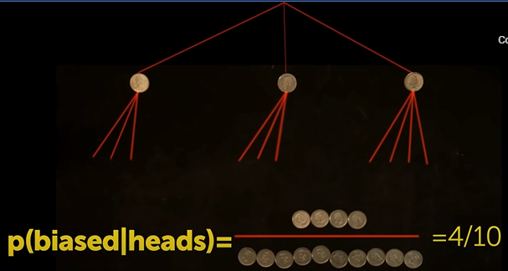

When In doubt, you can always answer conditional probability question by bayes theorem
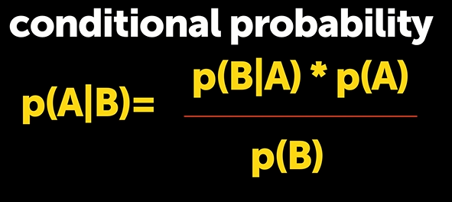

It tells the probability of event A given some new evidence B.
If you forgot it , no worries, you can use tree analogy.

Conditional proabability tree diagram example
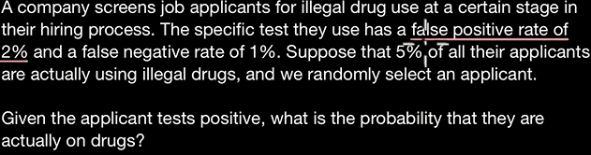
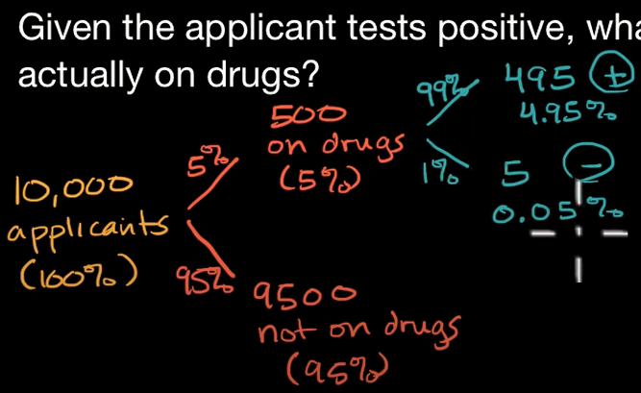
You can also get how many percent
p(False Negative | addict)
=5%*1%=0.05% are false positive in 10k ppl

Similarly,
p( positive | addict)= 5%*99%=4.95 % of ppl out of 10k who were on drugs and test positive or detected.
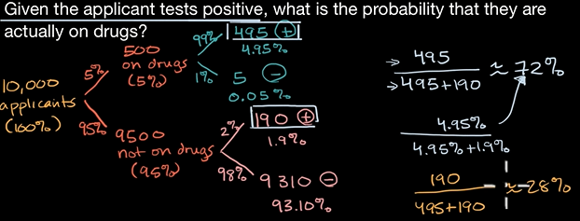
Even though the false positive and false negative are 2% and 1%. the probability that they were actually on drugs is 72%.
There is 28% chance I am not taking drugs.
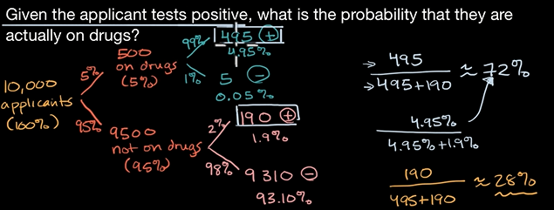
The reason its 28%, cuz most don’t take the drugs and due to false positive relative to the percentage who take the drug and test positive.

Conditional probability and independence
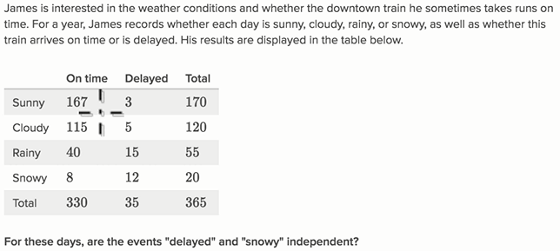
Above, is experimentally proabability, the more experiments you take there is more chance to approximate close to theoretical probability.
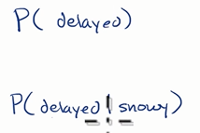
We need to find this,
If we knew the theoretical proabability, if the P(Delayed) is equal to P(Delayed | Snowy), then we can say they are independent events, proabability of one doesn’t affect the other.

If the two are pretty close through experimentally proabability we say its independent else dependent
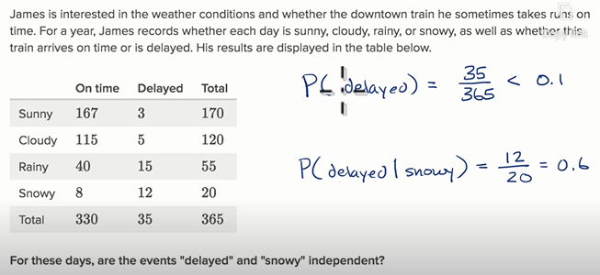
The probability of train being delayed on snowy days is so high, compare to general days. We can say they both are dependent events.

Analyzing event proabability for independence


